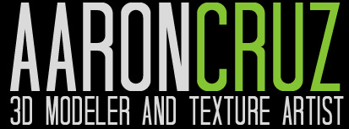
Cell: (503) 750-9639
Web: POGIMONZ.WEEBLY.COM Link
Email: POGMONZ@GMAIL.COM

EDUCATION:

The Art Institute of Seattle, Seattle , Washington March 2003
Associates of Applied Arts - Emphasis in 3d Modeling

SKILLS:

- High to Low Poly Modeling
- Texture Painting
- Zbrush Sculpting
- Mesh Retopology
- UV Unwrap and Normal Mapping
- LOD Creation and Collissions
- Efficient with a team or independently
- 6 + Years of game industry experience
- Adaptable and a lifelong learner
- Willing to work long hours to meet deadlines
- Creative at problem solving

SOFTWARE:

- 3ds Max
- Photoshop
- Zbrush
- Xnormal
- Crazy Bump
- Quixel NDO

Work Experience:
Self Employed Freelancer - 3D Artist
Seattle, WA, USA Mar. 2014 - Present
- Created 3d game assets for various AAA game titles.

Liquid Development - Staff 3D Artist
Portland, OR, USA Feb. 2010 - Mar. 2014
- Modeled and textured characters, environment, and props for various clients.

Floored Architecture - Contract 3D Artist
New York, NY, USA Oct. 2013 - Sep. 2014
- Modeled and textured 3D Architecture for clients.
- Tasked to create 200+ detailed low poly furniture for Floored's architecture projects.

Wacom Graphics Tablet - Research and Demo Artist
Portland, OR, USA Feb. 2012 - Mar. 2013
- Hired as 3d artist for promotional videos shoots.
- Aided Wacom research team with 3d artist insights on the Wacom Cintiq products.

Shipped Titles:

- Batman Arkham Origins, Firefall, Wildstar, Ryse Son of Rome, Shoot Many Robots, Rockband The Beatles, Rockband 3, Might & Magic Legacy.
- Floored NY Architecture Projects
- Rosetta Stone ReFLEX products

